|  |
| --- |
| Circle Language Spec: Commands |

## Command References in a Command Definition in a Diagram

This article demonstrates a situation of command objects.

This article illustrates how command references in a command definition look in a diagram.

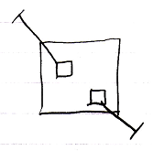

The larger square is a command definition. The smaller square inside them are command references in a command definition. They are actually *public* command references. This makes the command references *parameters* of the command definition. The command references have object lines, solid ones, going outside, ending at an access mark. Those object lines are indications of parameter passing, indicating that the command references are so called Reference parameters. Parameter passings are explained in the *parameter* articles.